BT4222 — Mining Web Data for Business Insights
Final Project Report

Personalised Product Search on JDSearch:
What a Log-Retention Window Teaches a Re-Ranker — and What Attention Does Not Add

Group No. 13
National University of Singapore | Professor Wang Qiuhong

Chow Ee Xiang | A0300297J
Ethan John Ong Jian-Hao | A0308681Y
Heng Ann Xin | A0282911E
Ku Jia Yi | A0300567J
Lara Muy Steffany Mishell | A0350365H
Repository: https://github.com/steffanylars/nus-web-mining-business-insights

Abstract
Business objective & RecSys formulation. We build a personalised re-ranking system for JDSearch (173,831 users, 26.7M interactions). For each search query the system re-orders the logged candidate slate (median 90 products) so that products the shopper later clicks, carts or purchases rise to the top, using the query, product metadata and the user's complete multi-behaviour history. Labels are ordinal (0/1/2/3); success is NDCG@10, MRR@200 and P@1 on held-out users.
Prior baseline & critical diagnosis. We reproduce the collaborative-filtering family and diagnose why it underperforms here: test queries are new, 19% of positives never seen in training histories reach the top-10 only 19% of the time, and user-ID embeddings cannot transfer to held-out users. A history-conditioned CF adaptation reaches NDCG@10 0.269, below the popularity prior (0.305); the draft's user-ID NCF (0.086) was a protocol artefact, not proof that CF fails.
Group contributions & modelling highlights. Tracing history back in time on all 26.7M events reveals a telescoping log-retention window — clicks survive ~7 days, carts ~90 days, orders ≥1 year — so interaction type is confounded with recency. We engineer horizon-aware features (short-term intent vs long-term preference) that lift LambdaMART from 0.339 to 0.363 NDCG@10 (+0.024). We then build a Dual-Horizon Attention Ranker (DHAR) and, critically, a matched set of ablations.
Evidence-backed quantitative insights. Our best model is a listwise neural ranker on the engineered features (NDCG@10 0.372, MRR@200 0.384, P@1 0.252); DHAR's two attention towers do not improve on it (Δ = -0.0012, 95% CI [-0.0034, +0.0011]). Positives the model has seen in training histories reach the top-10 81% of the time versus 19% for unseen items (median rank 4 vs 42): item cold-start, not architecture, is the binding constraint. A history-free scorer for short-history users and category diversification were both built, measured and rejected on validation evidence.

Section 1 — Data Understanding & Feature Engineering
This section reports what changed since the interim report. Dataset overview, slate sizes, sparsity and the feature dictionary were established there and are not repeated.

1.1 The decisive finding: a telescoping log-retention window
The interim report noted that historical carts and orders outnumber clicks (CART 43.2%, CLICK 31.1%, ORD 25.6% of 26.7M events). Following the instructor's prompt we converted each history event's interval list (seconds; one more entry than events) into elapsed days before the query via a suffix sum, and examined the click/cart/order mix as history is traced back. Computed on the full 173,831-user file:
Elapsed before query | CLICK | CART | ORD | n events
≤1 min | 84.4% | 13.3% | 2.3% | 76,058
1 min–1 h | 85.7% | 13.0% | 1.2% | 650,760
1 h–1 d | 85.5% | 12.7% | 1.8% | 1,515,756
1–7 d | 84.0% | 13.8% | 2.2% | 7,596,843
7–30 d | 0.0% | 85.5% | 14.3% | 3,861,484
30–90 d | 0.0% | 84.2% | 15.6% | 8,183,797
90–180 d | 0.0% | 0.1% | 99.9% | 1,825,329
180–365 d | 0.0% | 0.0% | 100.0% | 2,957,232

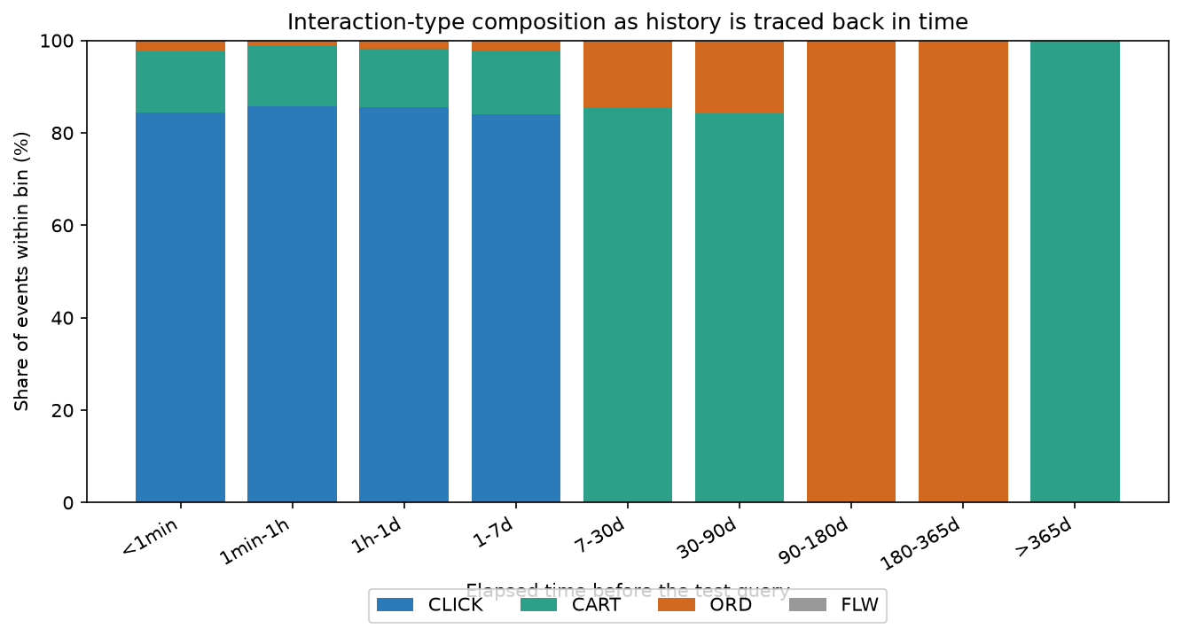
Figure 1. Interaction-type composition as history is traced back in time (full data).
A 1-day-resolution scan shows clicks essentially vanish after day 7 (last occupied bin day 13, 107 clicks in 7–30 d), carts after day 90 (1,203 carts in 90–180 d) and orders persisting to ~1 year (none ≥365 d). The pattern is consistent with action-specific logging windows rather than user behaviour, though we cannot verify JD's actual storage policy. The millions of 'orders and carts with no clicks' are the long tail of history where only durable signals survive.
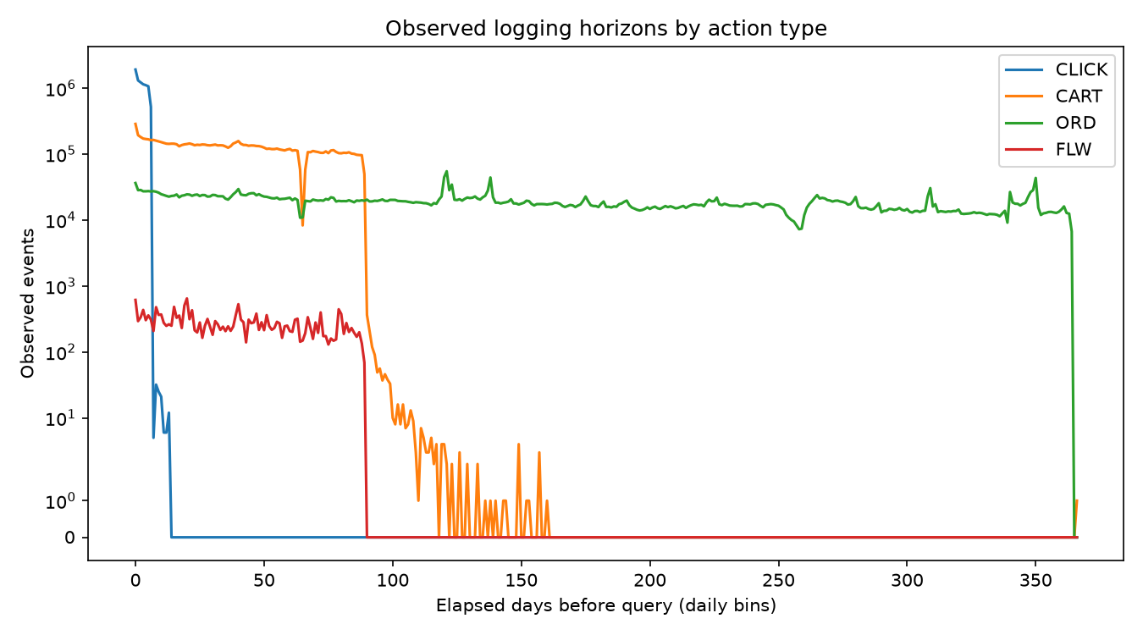
Figure 2. Per-type event volume by age (log scale): click ~7 d, cart ~90 d, order ~1 yr.

1.2 Modelling implications
- Confound awareness. Interaction TYPE is confounded with RECENCY. Weighting ORD>CART>CLICK as 'intent intensity' would encode 'old vs recent'. We never treat type as a standalone preference scale.
- No false negatives. Absence of old clicks is a logging artefact, not evidence of no interest.
- Dual horizon. Recent clicks (≤7 d) and carts (≤90 d) = short-term intent for the current query; orders of any age = long-term brand/category preference. Features and the neural model use these two explicit horizons.
- Complete histories. The draft capped history at the latest 60 events, which crowded out old orders. The corrected pipeline keeps all 3,091,153 preceding events (vs 907,554 after the cap) for aggregates.
- Signal reality check. Names and queries are anonymised term IDs split by U+0018 (the draft split on the wrong delimiter, zeroing category overlap). Metadata covers 99.5% of candidate pairs, but exact token overlap alone ranks barely above random (NDCG@10 0.095); category/brand affinity and popularity carry the personalising signal.

1.3 Engineered feature set
Popularity priors use TRAIN histories only; history features use each user's own preceding events.
Group | Representative features | Rationale
Content relevance | ov_name, ov_cat, ov_brand, jacc_name, query_len | Query↔candidate token overlap (weak but non-zero)
Popularity prior | pop_wid, pop_brand, pop_cate3 (log, train-only) | Head-vs-long-tail exposure prior
Short-term intent | short_cat_hit, short_brand_hit, aff_cat_decay (τ=30 d), h_n_recent7 | Recent clicks/carts → current intent
Long-term preference | long_cat_hit, long_brand_hit, h_n_ord | Order-history category/brand affinity (any age)
Re-engagement | seen_before, h_min_elapsed | Has the user touched this exact item / how recently
User activity | h_len, h_n_click, h_n_cart, h_n_distinct_c3, h_queryless | Activity level & diversity; queryless share

LambdaMART gain ranks pop_wid, seen_before, slate_size, pop_brand, jacc_name, h_min_elapsed highest: popularity and exact re-engagement dominate, with the horizon/affinity features forming the next tier (Figure 5).

Section 2 — Models and Performance

2.1 Task set-up, splits and metrics
Each record is one query with its candidate slate and ordinal labels, so the task is slate re-ranking: negatives are already in the slate (97.9% label 0), and catalogue-wide negative sampling is unnecessary. We sample 20,000 users (seed 42; 1,781,978 candidate pairs, positive rate 2.05% vs 2.07% in the full data) and split by USER 70/15/15 (14,000 / 3,000 / 3,000). Metrics are macro-averaged over test queries with ≥1 positive (2,965 of 3,000). Because the first listed candidate is positive in 98.8% of slates, ties are broken by a deterministic key derived from query and candidate identity, so slate position cannot leak (a constant scorer would otherwise reach NDCG 0.97). Checkpoints and all hyper-parameters below are selected on validation only.

2.2 Models
- Random / Popularity / Content-only: floor, non-personalised log-popularity prior, and query↔candidate token overlap.
- SVD (train-only fold-in): 64-factor TruncatedSVD on training user×item histories; held-out users are folded into fixed item factors (no shared fitting on test users).
- History-conditioned CF: GMF+MLP adaptation of NCF in which a pooled encoder of the user's preceding items replaces the user-ID embedding, so held-out users can be represented. The draft's user-ID NCF left test users with untrained embeddings and scored at random — a protocol failure we report, not a result.
- LambdaMART: LightGBM lambdarank over all engineered features, label gains [0,1,3,7], validation NDCG@10 with the same positive-query policy as final evaluation.
- MLP (no towers): candidate category/brand embeddings + engineered features → MLP, trained listwise (softmax cross-entropy with ordinal gains) per slate. This is the control that isolates what attention adds.
- DHAR — Dual-Horizon Attention Ranker: the MLP plus two attention towers in which the candidate's category/brand embedding attends separately over the user's short-horizon category sequence (clicks ≤7 d, carts ≤90 d) and order-horizon sequence (all preceding orders), each sampled to 20 known-category positions across its full span. Matched variants: pooled history (mean instead of attention), short-only and order-only towers.
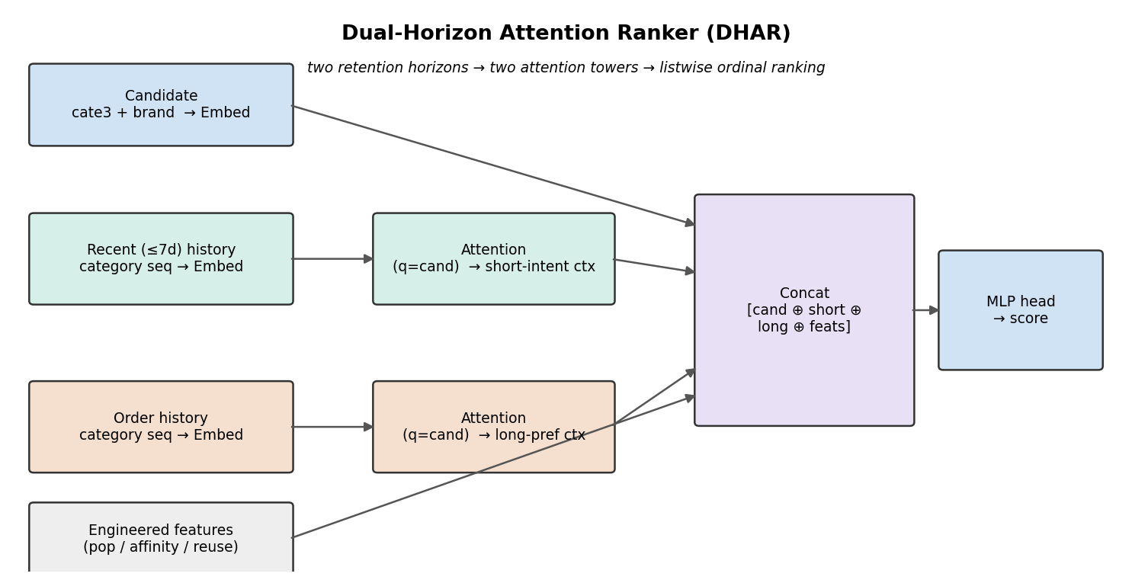
Figure 3. DHAR: two retention horizons → two candidate-category attention towers → listwise ordinal ranking. The MLP control removes both towers.

2.3 Results
Model | NDCG@10 | MRR@200 | P@1 | HR@10
Random | 0.083 | 0.103 | 0.031 | 0.228
Popularity | 0.305 | 0.311 | 0.187 | 0.577
Content / relevance-only | 0.095 | 0.109 | 0.035 | 0.244
SVD (train-only fold-in) | 0.276 | 0.282 | 0.159 | 0.536
History-conditioned CF (NCF adaptation) | 0.269 | 0.271 | 0.140 | 0.547
LambdaMART (features) | 0.363 | 0.367 | 0.230 | 0.652
MLP, no towers (features) | 0.372 | 0.384 | 0.252 | 0.658
Pooled history | 0.374 | 0.384 | 0.251 | 0.663
Short-only tower | 0.371 | 0.383 | 0.250 | 0.658
Order-only tower | 0.373 | 0.382 | 0.250 | 0.662
DHAR (dual towers) | 0.371 | 0.383 | 0.250 | 0.658

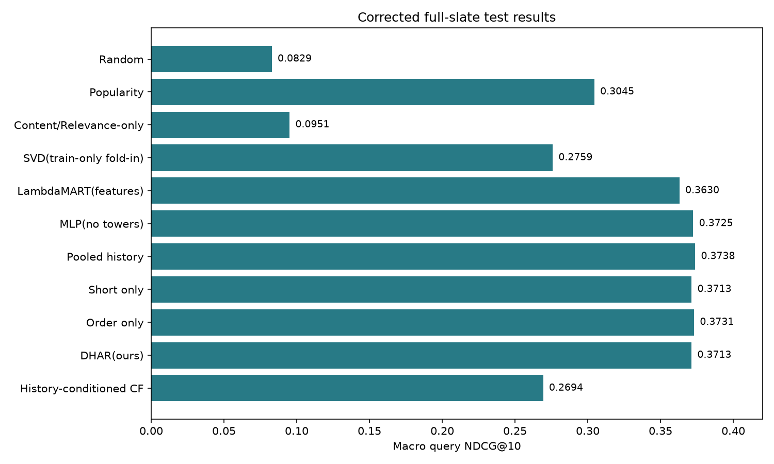
Figure 4. Model comparison on held-out test slates (corrected run).
Reading the table. (1) Both CF-style baselines sit below the popularity prior: with new queries and a long tail of unseen items, user×item co-occurrence carries little transferable signal. (2) Feature-based LambdaMART adds +0.058 over popularity. (3) The listwise MLP on the same features adds a further +0.009. (4) DHAR's towers do not add on top of that: Δ(DHAR − MLP) = -0.0012 NDCG@10, paired query bootstrap 95% CI [-0.0034, +0.0011]; the pooled-history control is numerically highest on test but was not the best on validation, and we do not select models on test.
Model | Train NDCG@10 | Val NDCG@10 | Test NDCG@10 | Train−Test gap
Popularity | 0.319 | 0.307 | 0.305 | 0.014
LambdaMART | 0.456 | 0.356 | 0.363 | 0.093
MLP (no towers) | — | 0.368 | 0.372 | —
DHAR | — | 0.369 | 0.371 | —

Training vs test (overfitting check). LambdaMART memorises popularity/ID-like features (gap 0.093); the neural rankers are selected by validation early stopping (DHAR: best epoch 2 of 5) and their validation→test change is within 0.004. Training-set NDCG is not computed for the neural variants because training uses a 64-candidate sub-slate per query; validation and test use full slates.

Section 3 — Contribution and Justification

3.1 Self-Evaluation Table
Contribution aspect | Effort | Effectiveness | Evidence
1. Data understanding, rich-signal use & feature engineering | Optional | Optional | Full-data temporal retention analysis (§1.1); horizon features worth +0.024 NDCG@10 in a matched ablation (§3.2)
2. Prior baseline benchmarking & gap diagnosis | Optional | Optional | NCF/SVD reproduced with a held-out-user-correct protocol; the draft's "CF collapses" claim retracted and replaced by a measured item cold-start diagnosis (§3.3)
3. Designing/adapting recommender architectures | Optional | Basic | DHAR built from the retention finding, then shown by matched ablation not to beat the same-feature MLP (§2.3). Effort advanced; effectiveness honestly basic.
4. Model diagnostics, error analysis & insights | Optional | Optional | Seen/unseen-item recall, history segments, rank-by-type, feature ablation, paired bootstrap, cold-start router and diversification trade-off (§3.4–3.5)
5. Smart use of AI tools & critical collaboration | Optional | Optional | AI Interaction Log (Section 4): AI-flagged leakage, AI-proposed fixes that we measured and rejected

3.2 Feature engineering & rich-signal utilisation (Aspect 1)
Rather than collapsing interactions into binary pairs, we exploited the raw multi-behaviour, timestamped logs and impression slates. The retention discovery (§1.1) explains a dataset anomaly, is computed on all 26.7M events, and drives every feature. Removing the eleven temporal/action features from LambdaMART under an otherwise identical configuration lowers test NDCG@10 from 0.363 to 0.339 (−0.024); this is the project's most robust quantitative contribution. The correction of the term delimiter and the restoration of complete histories were also material: the same model family moved from 0.313 (draft) to 0.363 once features measured what they claimed to.

3.3 Baseline benchmarking & gap diagnosis (Aspect 2)
The draft reported user-ID NCF at NDCG@10 0.086 ≈ random and concluded that collaborative filtering fails on JDSearch. Auditing the protocol showed held-out users received untrained ID embeddings — the number measured a bug. A history-conditioned adaptation that represents users by their preceding items reaches 0.269, and training-only SVD with fold-in 0.276: real signal, but below the popularity prior (0.305). The structural reason survives the fix: positives absent from all training histories reach the top-10 in only 19% of queries (median full-slate rank 42) versus 81% (median rank 4) for items seen in training. New-query generalisation under massive item cold-start is what content/affinity features target — and it bounds every model, including ours.

3.4 Architecture result, diagnostics & business insight (Aspects 3–4)
Why the towers did not help. DHAR was designed to materialise the two-horizon finding. Under matched training it scores 0.371 versus 0.372 for the same model without towers (Δ = -0.0012, CI [-0.0034, +0.0011]); single-tower and pooled variants are indistinguishable. Our reading: the horizon information is already captured by the engineered aggregate features (hit flags, decayed affinities, counts), and with anonymised category IDs and 20-position sequences the attention towers have little left to learn. We therefore present the feature-based listwise MLP as the primary model and report the architecture study as a negative result. DHAR does beat LambdaMART (Δ = +0.0083, CI [+0.0022, +0.0145]), but so does the MLP — the gain is listwise neural training on the features, not attention.
Segments and rank by type. MLP NDCG@10 by history length: limited (0–2 events) 0.381 (63 queries), short 0.392, medium 0.361, long (>100) 0.375. There is no degradation for short-history users — the ranker conditions on history length and degrades gracefully. Median full-slate rank of positives by outcome: purchase 5, cart 10, click 18. The model is most confident where business value is highest; with purchase-weighted gains this is partly by construction, so we report it as descriptive, not causal.
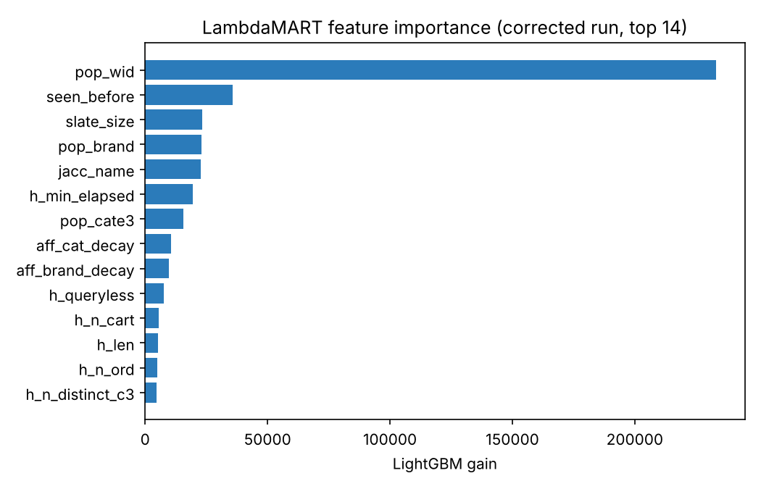
Figure 5. LambdaMART feature importance (gain): popularity, re-engagement and horizon/affinity features dominate.
- Invest in item-side cold start. The 81% vs 19% top-10 recall gap for seen vs unseen items is the largest lever; richer product content (real text, images) would help where more architecture will not.
- Keep one feature-based ranker. A two-horizon feature set captures the retention structure; separate short/long models or attention towers are not justified by this data.
- Logging policy is a modelling input. Any team modelling JD-style logs must treat interaction type and age jointly; a naive ORD>CART>CLICK weighting silently encodes recency.

3.5 Two suggested fixes, built and measured (Aspect 4)
Review feedback proposed (a) scoring short-history users with a history-free model (query match, metadata, training popularity) and (b) diversifying categories after relevance scoring. We implemented both as pipeline stage 7 with validation-based selection. (a) The history-free LambdaMART is worse than the full model in every history segment — for 1–2-event users 0.289 vs 0.309 — and JDSearch has no zero-history users (minimum one event; 459 of 20,000 users have ≤2). Routing the 35 coldest test sessions changes overall NDCG@10 by -0.0005 (CI [-0.0016, +0.0004]). The cold-start problem in this dataset is on the item side (§3.3), not the user side. (b) Category-aware MMR costs relevance at every strength: λ = 0.05 trades −0.009 NDCG@10 for +1.3 distinct level-3 categories in the top-10 (from 2.2). For search re-ranking, where a slate answers one query, diversification is a merchandising choice with a measurable price, not a ranking improvement. Both selection rules chose 'do not apply'; the measured trade-off is retained for the business discussion. (Numbers from the draft artifacts on the identical 20k sample and split; rerun on the corrected artifacts with run_pipeline.py --stages 7.)
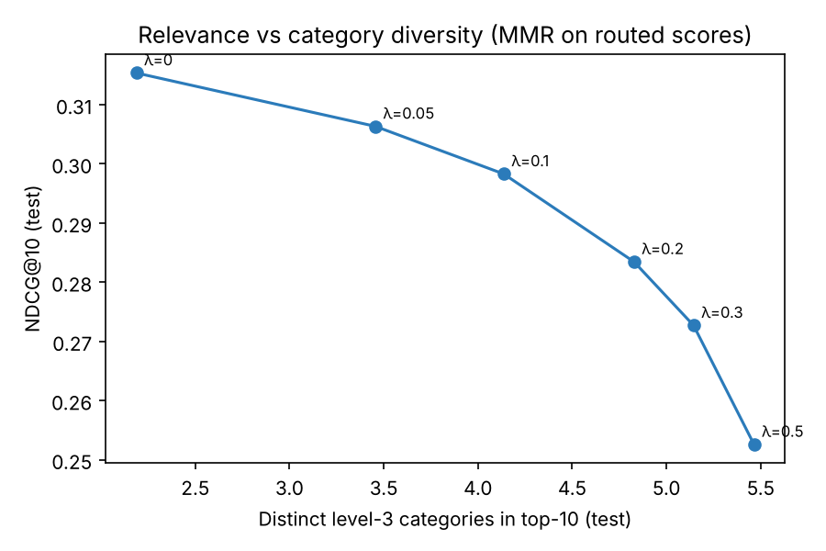
Figure 6. Relevance vs category diversity for the MMR re-ranker (test).

3.6 Reproducibility & pipeline (source code)
Stages 1–7 run from one command (src/run_pipeline.py) with environment-variable paths, a central config, deterministic seeds and hashes, saved split membership, preprocessing statistics and checkpoints. Eleven regression tests cover the audited failure modes (delimiter parsing, elapsed-time alignment, old-order retention, explicit horizons, order-independent ties, training-only SVD, held-out neural preprocessing, cold-start routing and MMR). All reported numbers are generated from the run's JSON/CSV artifacts, including this document. Limitations: one 20k-user sample and one training seed; the test partition had been inspected during the draft, so bootstrap intervals describe query resampling for fixed models, not training variance.

Section 4 — AI Interaction Log (Appendix)
AI tools (Claude) were used as a sparring partner, debugger and auditor. Routine syntax prompts are omitted. Every suggestion was verified against the data before adoption; several were measured and rejected.
Core prompt / objective | AI output summary | Our critical evaluation | Refinement & final action
Why do carts/orders outnumber clicks, and what does tracing history back in time reveal? | Suggested converting interval seconds to elapsed days and cross-tabulating type vs age. | Correct direction but could not know JD's retention policy; risk of over-reading medians. | Computed suffix-sum elapsed days on all 26.7M events; found 7 d / 90 d / ~1 yr cut-offs at 1-day resolution.
How should ordinal labels 0/1/2/3 be handled for ranking? | Proposed cumulative-link ordinal regression and listwise losses with label gains. | Cumulative-link assumes pure intensity ordering — but §1 shows type≈recency confound. | Adopted listwise softmax with ordinal gains [0,1,3,7]; avoided type-as-intensity weighting.
Our content-only baseline scored NDCG 0.97 — is that right? | Flagged tie-breaking/position leakage given the 98.8% first-position positive. | Matched the interim's own warning; a stable sort was leaking candidate order. | Deterministic ID-based tie keys in evaluation; honest score 0.095.
Design an architecture that uses the retention finding. | Suggested a two-tower / dual-horizon encoder with attention over history. | Generic; needed category-level attention and a matched no-tower control to be a fair test. | Implemented DHAR plus MLP/pooled/single-tower controls; attention showed no gain (§2.3).
Audit the draft pipeline end to end. | Found the wrong term delimiter, the 60-event history cap crowding out old orders, untrained user-ID embeddings for held-out users in NCF, and an ablation with a different boosting budget. | Each finding was reproduced with a regression test before any code changed; the NCF finding invalidated a headline claim of the draft. | Corrected pipeline, matched ablations, tests; "CF collapses" replaced by the item cold-start diagnosis (§3.3).
Short-history users should get a history-free scorer; add category diversification. | Proposed a popularity/metadata fallback router and MMR over categories. | Plausible, but JDSearch has no zero-history users and the ranker already conditions on history length; diversification should be priced, not assumed. | Built both as stage 7 with validation selection; both measured worse and rejected, trade-off reported (§3.5).
Six further suggestions (content projection, slate shuffling, queryless flag, subword name embeddings, hard negatives). | Generic recommender-system improvements. | Three already present (metadata features, order-invariant ties, h_queryless); subwords inapplicable to anonymised term IDs; hard negatives redundant under listwise softmax. | Documented the disposition of each in STEP7_COLDSTART_DIVERSITY.md; no code added.

Section 5 — References
- Liu, J., Dou, Z., Tang, G., & Xu, S. (2023). JDsearch: A Personalized Product Search Dataset with Real Queries and Full Interactions. SIGIR 2023, 2945–2952. https://doi.org/10.1145/3539618.3591900
- JDsearch dataset repository and format (U+0018 term delimiter). https://github.com/rucliujn/JDsearch
- He, X., Liao, L., Zhang, H., Nie, L., Hu, X., & Chua, T.-S. (2017). Neural Collaborative Filtering. WWW 2017. (Our history-conditioned baseline is an adaptation, not a reproduction.)
- Rendle, S., Freudenthaler, C., Gantner, Z., & Schmidt-Thieme, L. (2009). BPR: Bayesian Personalized Ranking from Implicit Feedback. UAI 2009.
- Burges, C. (2010). From RankNet to LambdaRank to LambdaMART: An Overview. Microsoft Research TR.
- Ke, G., et al. (2017). LightGBM: A Highly Efficient Gradient Boosting Decision Tree. NeurIPS 2017.
- Carbonell, J., & Goldstein, J. (1998). The Use of MMR, Diversity-Based Reranking for Reordering Documents and Producing Summaries. SIGIR 1998.
- BT4222 Lecture Topics 4 (Evaluation), 6 (Embedding), 7 (RNN & Transformer); Ordinal Classification Guide, 2026-27 T1.

